

# 

### Semester Two Examination, 2016

### Question/Answer Booklet

# MATHEMATICS

If required by your examination administrator, please place your student identification label in this box

**SPECIALIST**

**UNITS 1 AND 2**

## Section Two:

## Calculator-assumed

|  |  |  |  |  |  |  |  |  |
| --- | --- | --- | --- | --- | --- | --- | --- | --- |
| Student Number: In figures |  |  |  |  |  |  |  |  |

In words

Your name

## Time allowed for this section

Reading time before commencing work: ten minutes

Working time for section: one hundred minutes

## Materials required/recommended for this section

***To be provided by the supervisor***

This Question/Answer Booklet

Formula Sheet (retained from Section One)

***To be provided by the candidate***

Standard items: pens (blue/black preferred), pencils (including coloured), sharpener, correction fluid/tape, eraser, ruler, highlighters

Special items: drawing instruments, templates, notes on two unfolded sheets of A4 paper, and up to three calculators approved for use in the WACE examinations

## Important note to candidates

No other items may be taken into the examination room. It is **your** responsibility to ensure that you do not have any unauthorised notes or other items of a non-personal nature in the examination room. If you have any unauthorised material with you, hand it to the supervisor **before** reading any further.

## Structure of this paper

|  |  |  |  |  |  |
| --- | --- | --- | --- | --- | --- |
| Section | Number of questions available | Number of questions to be answered | Working  time (minutes) | Marks available | Percentage of exam |
| Section One:  Calculator-free | 7 | 7 | 50 | 51 | 35 |
| Section Two:  Calculator-assumed | 13 | 13 | 100 | 98 | 65 |
|  | | | **Total** | 149 | 100 |

## Instructions to candidates

1. The rules for the conduct of examinations are detailed in the school handbook. Sitting this examination implies that you agree to abide by these rules.

2. Write your answers in this Question/Answer Booklet.

3. You must be careful to confine your response to the specific question asked and to follow any instructions that are specified to a particular question.

4. Spare pages are included at the end of this booklet. They can be used for planning your responses and/or as additional space if required to continue an answer.

* Planning: If you use the spare pages for planning, indicate this clearly at the top of the page.
* Continuing an answer: If you need to use the space to continue an answer, indicate in the original answer space where the answer is continued, i.e. give the page number. Fill in the number of the question that you are continuing to answer at the top of the page.

5. **Show** **all your working clearly**. Your working should be in sufficient detail to allow your answers to be checked readily and for marks to be awarded for reasoning. Incorrect answers given without supporting reasoning cannot be allocated any marks. For any question or part question worth more than two marks, valid working or justification is required to receive full marks. If you repeat any question, ensure that you cancel the answer you do not wish to have marked.

6. It is recommended that you **do not use pencil**, except in diagrams.

7. The Formula Sheet is **not** to be handed in with your Question/Booklet.

Section Two: Calculator-assumed 65% (98 Marks)

This section has**thirteen (****13)** questions. Answer **all** questions. Write your answers in the spaces provided.

Working time for this section is 100 minutes.

Question 8 (5 marks)

Points B, C and E lie on the circle with diameter AOD as shown below. $∠ABC=115°$, $∠BAC=20°$ and $∠ACE=60°$.

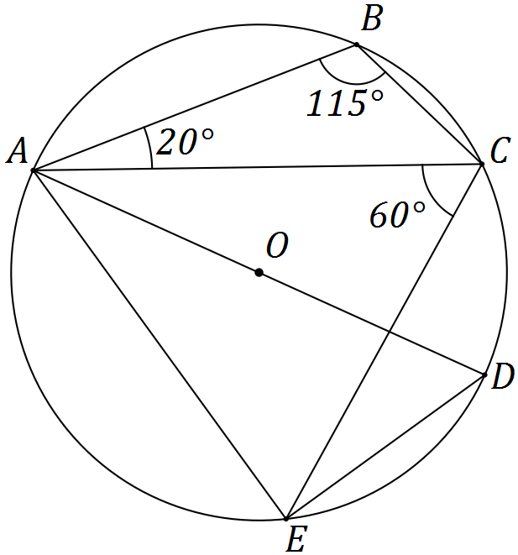

Determine the size of the following angles.

(a) $∠ADE$. (1 mark)

(b) $∠EAD$. (1 mark)

(c) $∠AEC$. (1 mark)

(d) $∠CAD$. (1 mark)

(e) $∠CED$. (1 mark)

Question 9 (7 marks)

(a) $ABCDEF$ is a regular hexagon. The midpoint of side $DE$ is $M$.

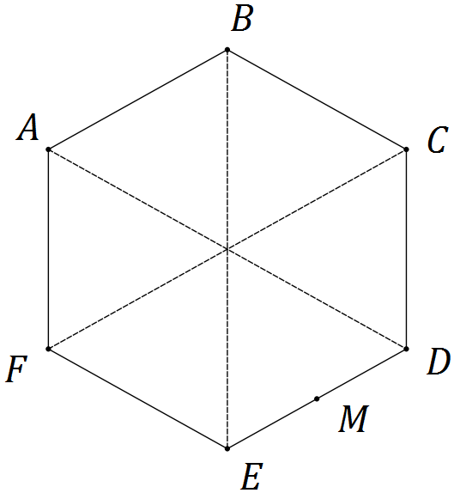

Let $a=\vec{AB}$ and $b=\vec{AF}$. Express each of the following in terms of a and b.

(i) $\vec{BC}$. (1 mark)

(ii) $\vec{AE}$. (1 mark)

(iii) $\vec{MB}$. (1 mark)

(b) Three forces, $F_{1}$, $F_{2}$ and $F_{3}$ act on a body that remains in equilibrium.

$F_{1}$ has a magnitude of 400 N. The angle between the directions of $F_{1}$ and $F_{2}$ is 150°, between $F_{1}$ and $F_{3}$ is 135° and between $F_{2}$ and $F_{3}$ is 75°.

Determine the magnitudes of $F_{2}$ and $F_{3}$, rounding your answers to the nearest whole number. (4 marks)

Question 10 (7 marks)

(a) A number is to be formed by randomly selecting three **different** digits from those in the number 93265. Determine how many different numbers

(i) start with an odd digit. (1 mark)

(ii) end with an even digit. (1 mark)

(iii) start with an odd digit or end in an even digit. (2 marks)

(b) A computer user has forgotten their six character, case-sensitive password, but know that they always use a permutation of F, F, 1, 9, 9, and 9 - their initials and the year they were born. Determine how many passwords are possible if

(i) the F's must both be uppercase. (2 marks)

(ii) either F can be lowercase or uppercase. (1 mark)

Question 11 (8 marks)

(a) Triangle BCE is such that B, C and E lie on a circle with centre O and radius 29 cm. Diameter AD and chord CE intersect at F, so that $DF=8.5$ cm and $EF=25.5$ cm.

Determine the lengths OF, CF and BC. (5 marks)

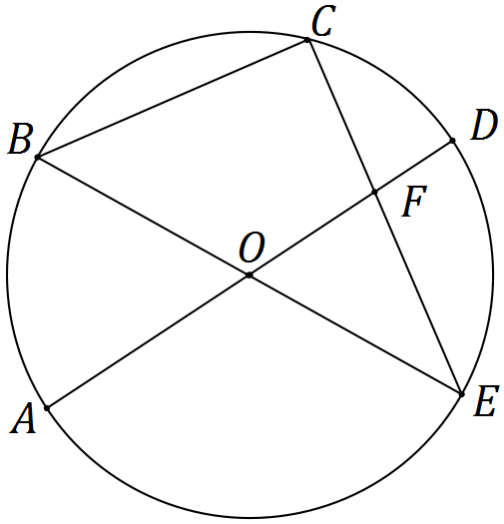

(b) In the diagram below, points B, C and D lie on a circle with centre O. The tangents to the circle at B and D intersect at point A. If $∠BAD=x$, prove that $∠BCD=90°-\frac{x}{2}$. (3 marks)

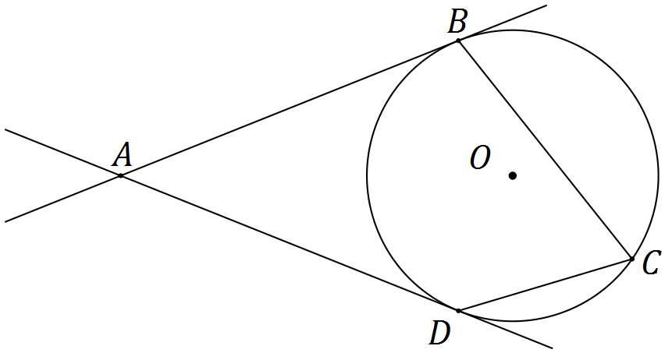

Question 12 (9 marks)

Transformation A is an anti-clockwise rotation about the origin of 90° and matrix $B=\left[\begin{matrix}2 & 0 \\ 0 & 3\end{matrix}\right]$.

(a) Represent transformation A as a $2×2$ matrix. (2 marks)

(b) Describe the transformation represented by matrix B. (2 marks)

(c) Determine the coordinates of the point $P(-15, -11)$ following transformation A and then transformation B. (2 marks)

(d) Following transformation B and then transformation A, point Q is transformed to point $Q'(12, 7)$.

Determine the single matrix that will transform $Q'$ back to $Q$ and hence determine the coordinates of point Q. (3 marks)

Question 13 (8 marks)

(a) On the axes below sketch the graph of $y=\frac{1}{2}\sec\left(x-\frac{π}{2}\right)$. (3 marks)

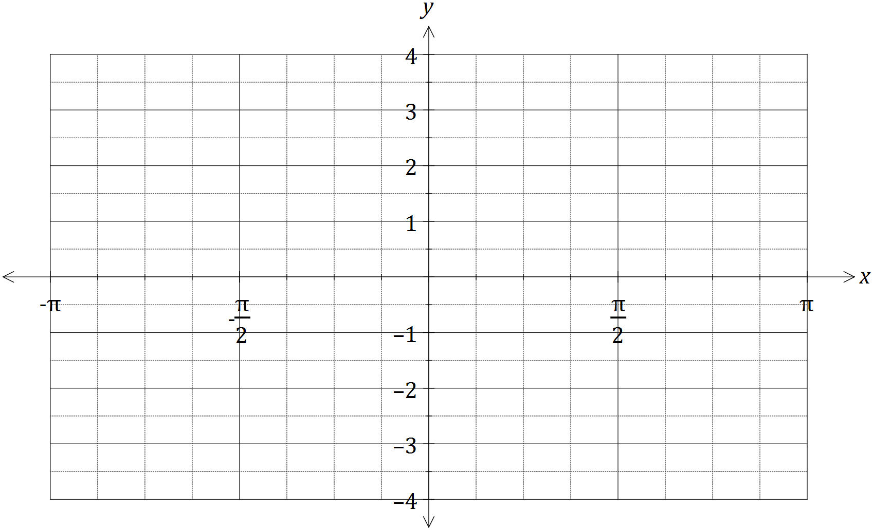

(b) Consider the function $f\left(t\right)=2\sin{t}-5\cos{t}$, $t≥0$.

(i) $f\left(t\right)$ can be expressed in the form $r\sin{(t-α)}$, where $r>0$ and $0≤α≤\frac{π}{2}$. Determine the values of $r$ and $α$, rounded to 2 decimal places. (3 marks)

(ii) Hence or otherwise determine the minimum value of $f(t)$ and the smallest value of t for this minimum to occur. (2 marks)

Question 14 (8 marks)

(a) Consider the vectors $p=(24, -143)$ and $q=(20, -21)$. Determine

(i) the angle between the directions of vectors p and q. (1 mark)

(ii) two vectors that are perpendicular to q and have the same magnitude as p.

(3 marks)

(b) If $\vec{AB}=(3, 4)$ and $\vec{AC}=(-2, 1)$, determine

(i) the component of $\vec{AB}$ parallel to $\vec{AC}$. (2 marks)

(ii) the component of $\vec{AB}$ perpendicular to $\vec{AC}$. (2 marks)

Question 15 (8 marks)

(a) Express the recurring decimal $1.1\overline{58}$ as a rational number. (2 marks)

(b) Use a counterexample to explain why the statement $(∀x∈Z)(∃y∈Z)(2xy=24)$ is false.

(2 marks)

(c) Prove, by contradiction, that $\sqrt{6}$ is irrational. (4 marks)

Question 16 (7 marks)

(a) Let the angle $θ=\frac{π}{3}-\frac{π}{4}=\frac{π}{12}$.

(i) Use your calculator to write down an exact value for $\sin\left(\frac{π}{12}\right)$. (1 mark)

(ii) Use an angle sum or difference identity to show how to obtain the above exact value for $\sin\left(\frac{π}{12}\right)$. (3 marks)

(b) Prove the identity $\sin{x}+\sin{2x}+\sin{3x}=\left(1+2\cos{x}\right)\sin{2x}$. (3 marks)

Question 17 (9 marks)

Trapezium OPQR has parallel sides PQ and OR such that $\left|\vec{OR}\right|=k|\vec{PQ}|$. Let $\vec{OP}=a$ and $\vec{PQ}=b$.

(a) Sketch the trapezium. (1 mark)

(b) Determine vectors for $\vec{OQ}$ and $\vec{PR}$ in terms of $k$, a and b. (2 marks)

(c) Show that the scalar product of $\vec{OQ}$ and $\vec{PR}$ is $k{\left|b\right|}^{2}-{\left|a\right|}^{2}+\left(k-1\right)a⋅b$. (2 marks)

(d) Simplify your result from (c) if $k=1$, $a=i+4j$ and $b=3i-2\sqrt{2}j$. (2 marks)

(e) Explain the geometric significance of your result from (d). (2 marks)

Question 18 (7 marks)

(a) The work done, in joules, by a force F Newtons in changing the displacement of an object s metres is given by the scalar product of F and s. Calculate the work done when a force of 750 N moves an object a distance of 85 cm at an angle of 5° to the force.

(2 marks)

(b) A drone flies with a constant velocity and height above level ground, over which a wind blows from the north west at 3.5 metres per second. After 15 seconds, the drone reaches a point 85 metres on a bearing of 020° from where it was launched. Determine the velocity of the drone, giving its magnitude to two decimal places and bearing to the nearest degree. (5 marks)

Question 19 (8 marks)

(a) A high school has 5 male and 9 female volunteers from which to choose a debating team of 5 students. Determine the number of different teams that can be formed if

(i) there are no special requirements. (1 mark)

(ii) there must be a captain and a vice-captain. (2 marks)

(iii) there must be more females than males, but at least one male. (2 marks)

(b) Determine how many **different** numbers must be selected from the first 25 positive integers to be certain that at least one of them will be twice the other. (3 marks)

Question 20 (7 marks)

In the diagram below, the tangents from point A touch the circle at B and F. Point E lies on the major arc BF and D lies on BF so that $DE⊥BF$. Points C and G lie on AB and AF extended respectively such that $EC⊥AC$ and $EG⊥AG$.

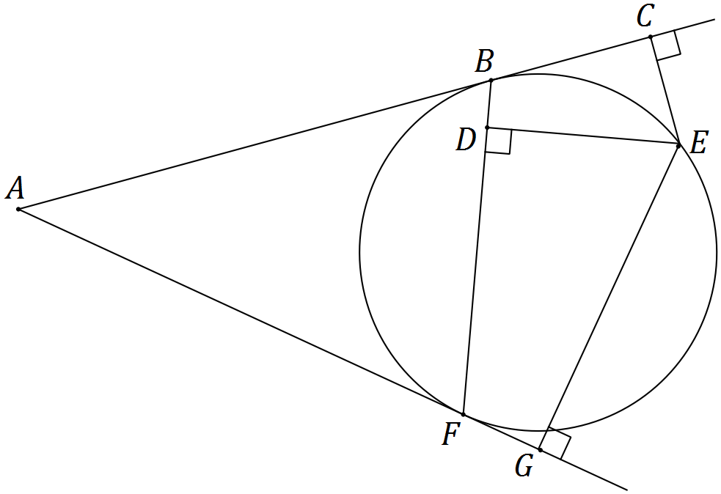

(a) Show that $ΔBCE$ and $ΔFDE$ are similar. (3 marks)

(b) Show that $DE^{2}=CE×GE$. (4 marks)

Additional working space

Question number: _________

© 2016 WA Exam Papers. Narrogin Senior High School has a non-exclusive licence to copy and communicate this paper for non-commercial, educational use within the school. No other copying, communication or use is permitted without the express written permission of WA Exam Papers.